**SPMP**

1. Introduction
   1. Product Overview
   2. Project Deliverables
2. Project Organization
   1. Software Process Model
   2. Roles & responsibilities
   3. Tools and techniques
3. Project Management Plan – all points below
4. Tasks
   1. Information Gathering
      1. Description
      2. Deliverables and milestones
      3. Resources needed
      4. Dependencies and constraints
      5. Risks and contingencies (c, d)
   2. Modelling Requirements
   3. Coding
   4. Testing
   5. Delivery
   6. Maintenance
5. Assignments

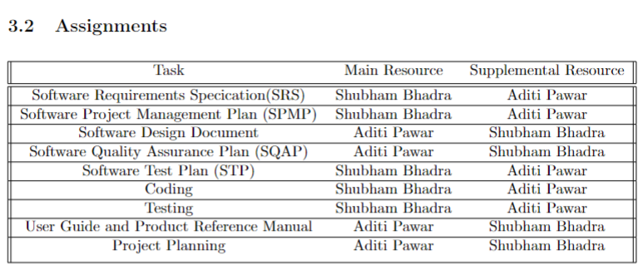

1. Timetable
   1. Gantt chart
   2. Tasks
   3. Pert Chart

**RMMM**

1. Risk Assessment (All different risks)
   1. Describe it
   2. Likelihood of risk (number btw 1-10)
   3. Potential Impact (number btw 1-10)
   4. Risk Exposure = (c) x (d)
2. Risk Management – reduction ways explained in depth
3. Risk Checklist

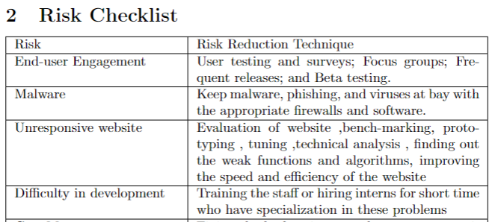

**SDD**

1. Introduction
   1. Design Overview
   2. Requirements traceability Matrix

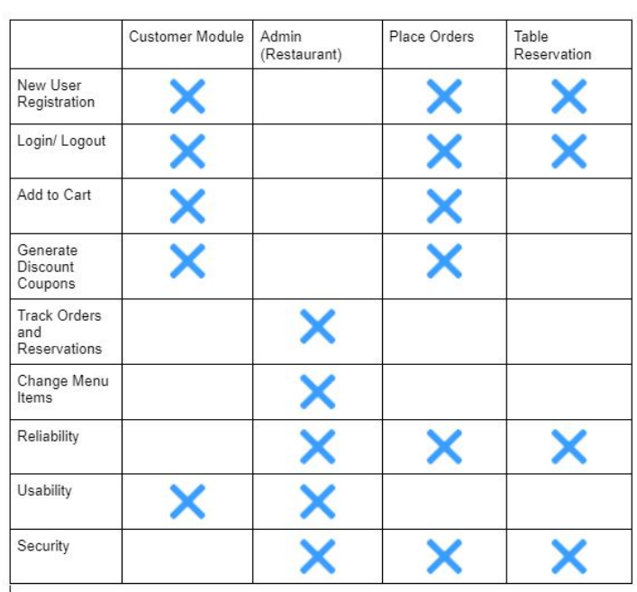

1. System Architectural design
   1. Chosen System Architecture
   2. Discussion of Alternative designs
   3. System Interface Description
2. Detailed Description of components
   1. Responsibilities
   2. Constraints
   3. Composition
   4. Interactions
   5. Resources
3. UI design
4. System Architecture
   1. Use Case Tables

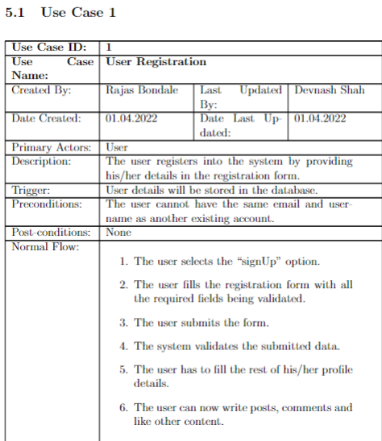

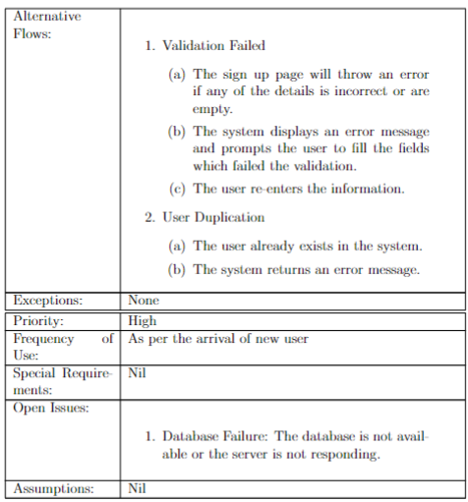

1. Data Flow specifications

**SRS**

1. Introduction
   1. Purpose
   2. Product Overview
2. Specific Requirements
   1. User Requirements
      1. System Requirements
      2. Software Requirements
      3. External Interface Requirements
   2. Software Product Features
   3. Functional Requirements
   4. Software System attributes - Non Functional Requirements
   5. Database Requirements

**STD**

1. Introduction
   1. System Overview
   2. Test Approach
      1. Unit testing
      2. White box
      3. Black box
2. Test Plan
   1. Features to be tested.

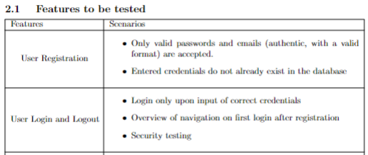

* 1. Features not to be tested

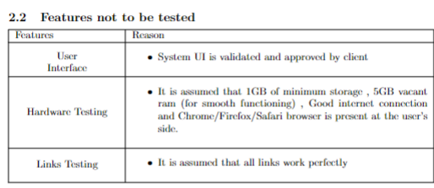

* 1. Testing tools and environment

1. Test Cases
   1. Test Case id
   2. Description
   3. Input
   4. Expect Output
   5. Output
   6. Status – pass/fail